GRACE VALLEY COLLEGE OF ARTS AND SCIENCE, MARAVATATM
DEPARTMENT OF PHYSICAL EDUCATION
Annual Report 2023-2024
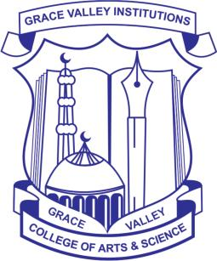
Grace valley College of Arts & Science, Maravattam
(Affiliated to the University of Calicut)
Chengottoor P.O, Malappuram Dt., Kerala. Pin : 676503
DEPARTMENT OF PHYSICAL EDUCATION

ANNUAL REPORT 2023-24

- COMMEMORATION OF INTERNATIONAL DAY AGAINST DRUG ABUSE AND ILLICIT TRAFFICKING--26-06-2023

Grace Valley College Of Arts & Science's Physical Education Department hosted a friendly football match to mark the International Day Against Drug Abuse And Illicit Trafficking On June 26th, 2023. The event aimed to instill a healthy, drug-free lifestyle, emphasizing teamwork, sportsmanship, and physical fitness. Students, faculty, and staff united in solidarity against drug abuse, with 20 participants divided into Blue and Green teams. Mr. Sreejith, the Head of the Chemistry Department, inaugurated the match. The Blue Team emerged victorious, receiving trophies from the college principal.
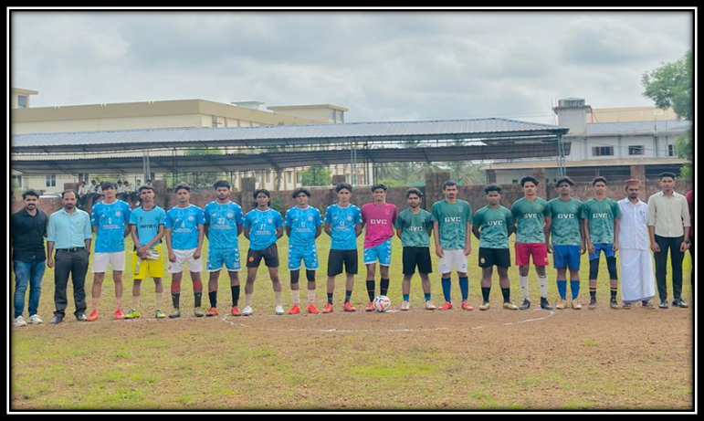

- FOOTBALL COACHING CAMP--11/08/2023-18/09/2023

The Department of Physical Education organized a Football Coaching Camp from 11/08/2023 to 18/09/2023. Approximately 30 participants took part in the camp, honing their skills under expert guidance. From this camp, the college football team was selected, showcasing the effectiveness of the camp in identifying and nurturing talent. This initiative highlights the college's commitment to fostering sporting excellence among its students.

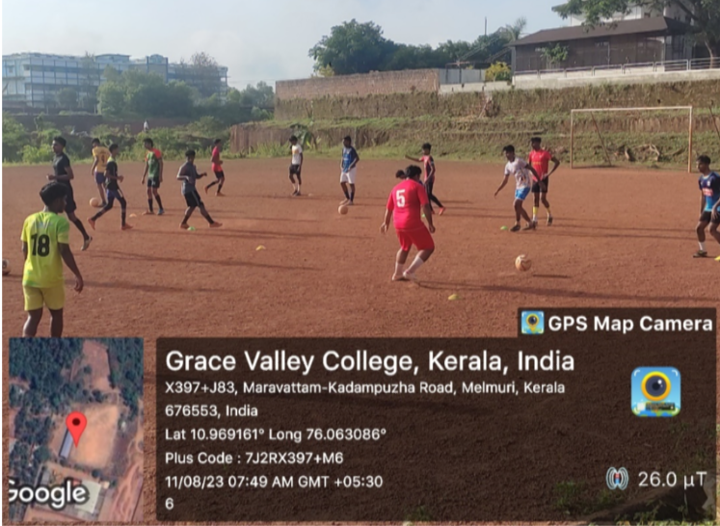

- NATIONAL SPORTS DAY CELEBRATION-- 29/08/2023

National Sports Day is celebrated in honor of the birthday of Major Dhyan Chand, one of India’s greatest hockey players of all time. To commemorate this occasion, Department of physical education organized a online Quiz Programme to promote sports awareness and celebrate the spirit of sportsmanship. The primary objective of the National Sports Day Quiz Programme was to educate,engage, and entertain participants while promoting a culture of sports and physical fitness.

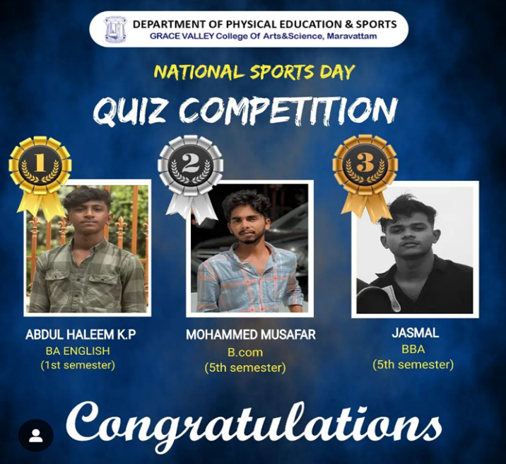

- COLLEGE FOOTBALL TEAM PARTICIPATED IN UNIVERSITY OF CALICUT
B-ZONE FOOTBALL CHAMPIONSHIP 2023-24 --10/10/2023

College football team participated in university of calicut B-zone football championship held at Sullamusalam college of arts and science Arekode.Team faced off against Nasra College of Arts and Science, Tirurkad. The intense match concluded with a 2-2 draw, leading to a tiebreaker .Unfortunately, despite their efforts, the team succumbed to a loss in the tiebreaker. Nonetheless, their display of skill and sportsmanship throughout the game was commendable.

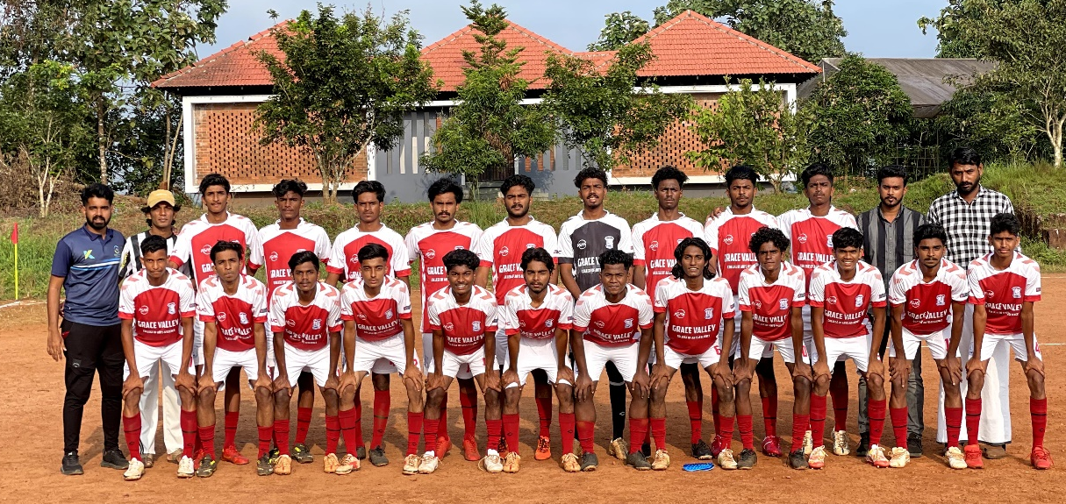

- VOLLEY BALL COACHING CAMP--11/08/2023-18/09/2023

The Department of Physical Education conducted a week-long Volleyball Coaching Camp for college students from September 17th to 24th, 2023. Approximately 28 students participated in the program. The camp aimed to enhance participants' volleyball skills through rigorous training sessions and practice matches. Various techniques and strategies were taught to improve both individual and team performance. Overall, the camp provided a platform for skill development and fostering a spirit of sportsmanship among the participants.
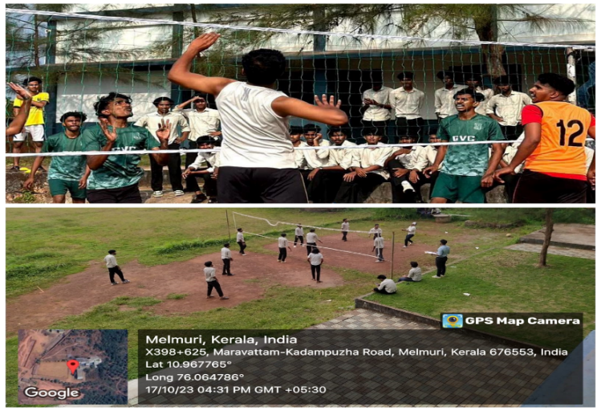

- COLLEGE VOLLEYBALL TEAM PARTICIPATED IN UNIVERSITY OF CALICUT
B-ZONE VOLLEYBALL CHAMPIONSHIP 2023-24 --26/10/2023

The college volleyball team participated in the University of Calicut B-Zone Volleyball Championship 2023-24 held at Mar Thoma College Chungathara. Team showcased their prowess by securing victories in the first three rounds against CAS Muthuvallur, IHRD Vazhakakad, and JIASC Manjeri respectively. Despite a commendable effort, they faced a setback in the pre-quarterfinals against Malabar College Vengara. Nonetheless, this marked the first-ever entry of the college's volleyball team into the pre-quarterfinals, signifying a significant achievement.

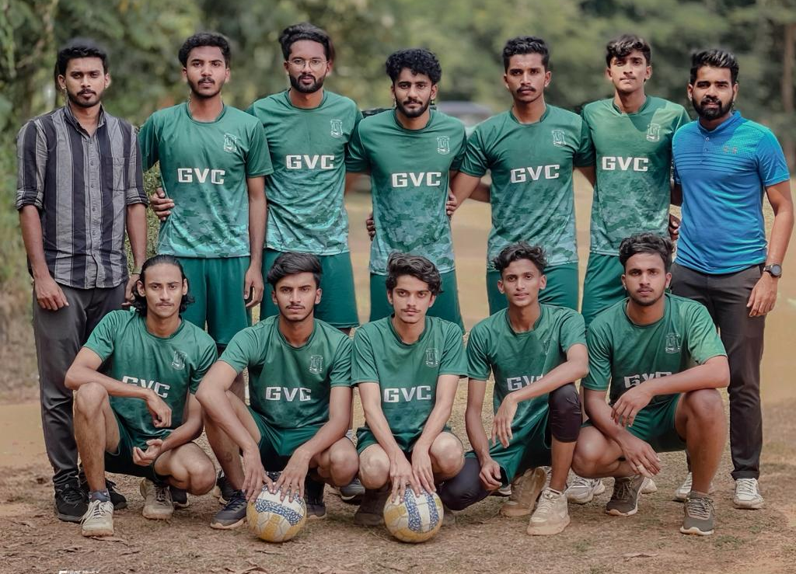

- CRICKET COACHING CAMP--18/10/2023-10/11/2023

The Department of Physical Education organized a Cricket Coaching Camp for college students from October 18 to November 10, 2023. Approximately 34 enthusiastic students participated in the camp, honing their cricketing skills under expert guidance. The camp fostered teamwork, discipline, and sportsmanship among the participants, enhancing their overall physical fitness and cricketing proficiency. Such initiatives promote a culture of sports and fitness within the college community, contributing to holistic student development.

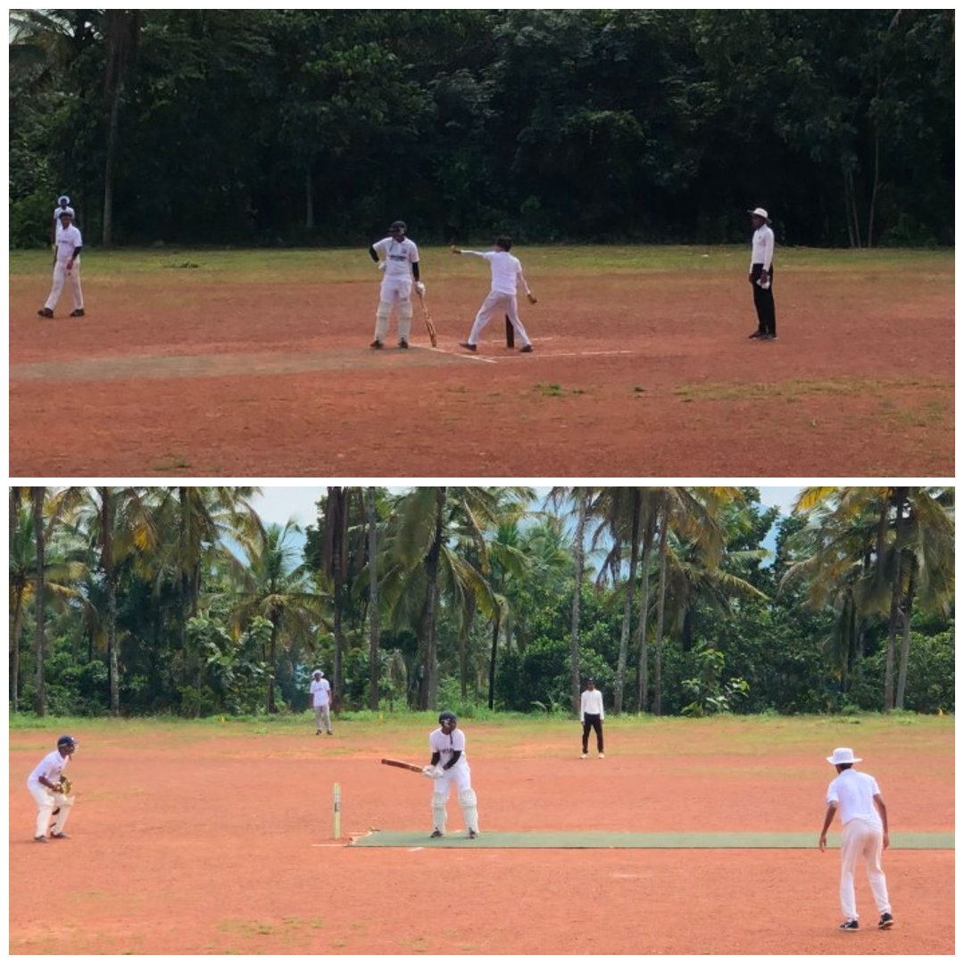

- COLLEGE CRICKET TEAM PARTICIPATED IN UNIVERSITY OF CALICUT
B-ZONE CRICKET CHAMPIONSHIP 2023-24 --08/11/2023

The college cricket team competed in the University of Calicut B-Zone Cricket Championship 2023-24 held at Alshifa College of Arts and Science, Kizhatur. Unfortunately defeated in the second round against Alshifa College of Arts and Science, Kizhatur. Despite the loss, Fayis(1st semester BCA student) showcased outstanding performance and was awarded the Man of the Match title for his remarkable contribution.

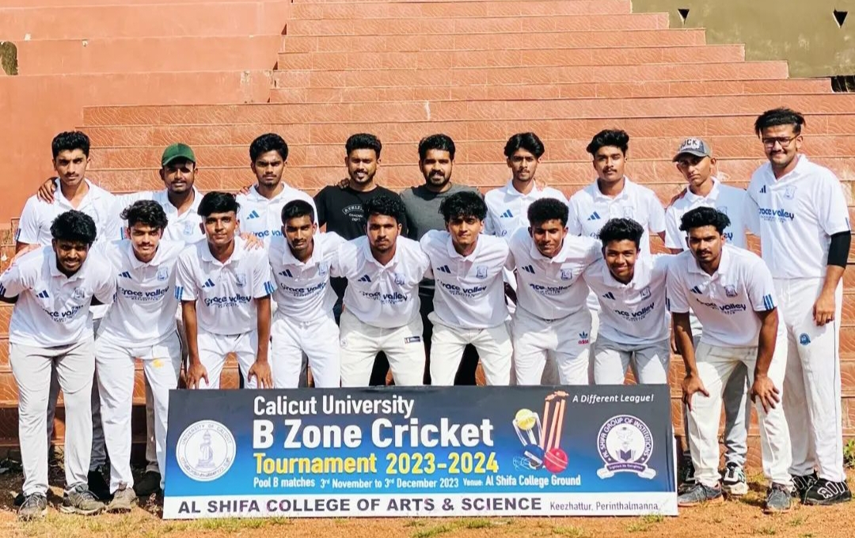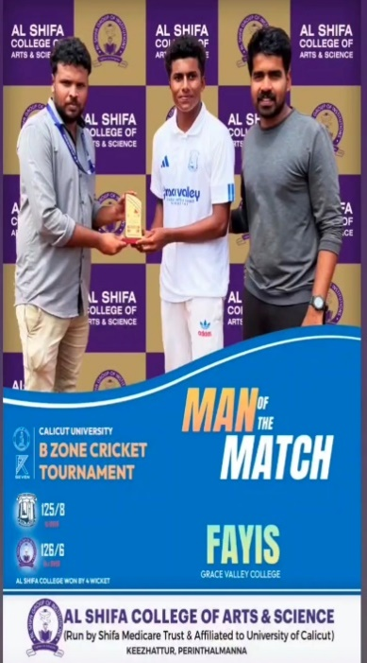

- COLLEGE CHESS TEAM PARTICIPATED IN UNIVERSITY OF CALICUT
INTER ZONE CHESS CHAMPIONSHIP 2023-24 --29/11/2023

The college chess team actively participated in the University of Calicut Inter Zone Chess Championship 2023-24 held at Alshifa College of Arts and Science, Kizhatur. Engaging in both individual and team events, the team showcased their strategic prowess and dedication. Despite facing stiff competition, they demonstrated exceptional skill and sportsmanship throughout the tournament. Their participation not only contributed to the competitive spirit of the event but also highlighted the talent within the institution.

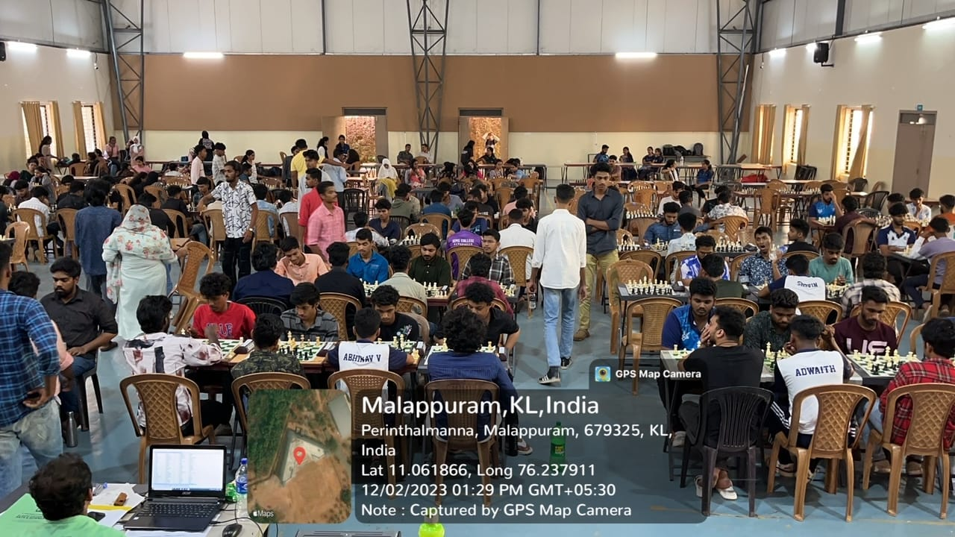
- INTER DEPARTMENT FOOTBALL TOURNAMENT--19/12/2023-22/12/2023

The Department of Physical Education hosted an exhilarating Inter-Department Sevens Football Tournament in collaboration with the Baahar Students Union. From December 19th to December 22nd, 2023, six teams showcased their skills and sportsmanship on the field. Participants represented a diverse array of academic disciplines including B.Com CA, B.Com Finance, BCA, BA English, BBA, and BAEFT. The event was a resounding success, fostering teamwork and camaraderie among students.

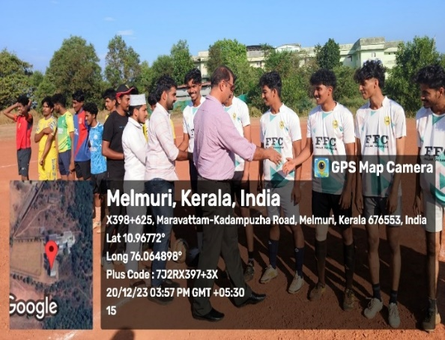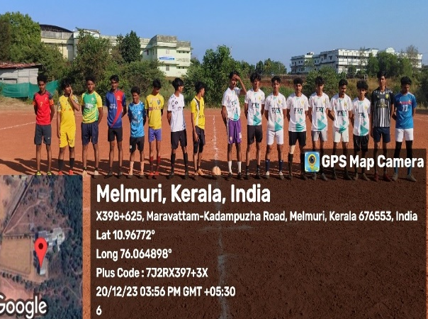

- COLLEGE BODEY BUILDING TEAM PARTICIPATED IN UNIVERSITY OF CALICUT
INTER ZONE BEST PHYSIQUE CHAMPIONSHIP 2023-24 –18/01/2024

The College Bodybuilding Team participated in the university of calicut Interzone Best Physique Championship 2023-24 at heldat MES KVM College Valanchery. Dhiljith Surya (first-year BA English) s competed in the 60 kg category, while Faris( first-year BA English) participated in the 65 kg category. The team displayed impressive dedication and skill, representing the college with pride and determination in the competition.

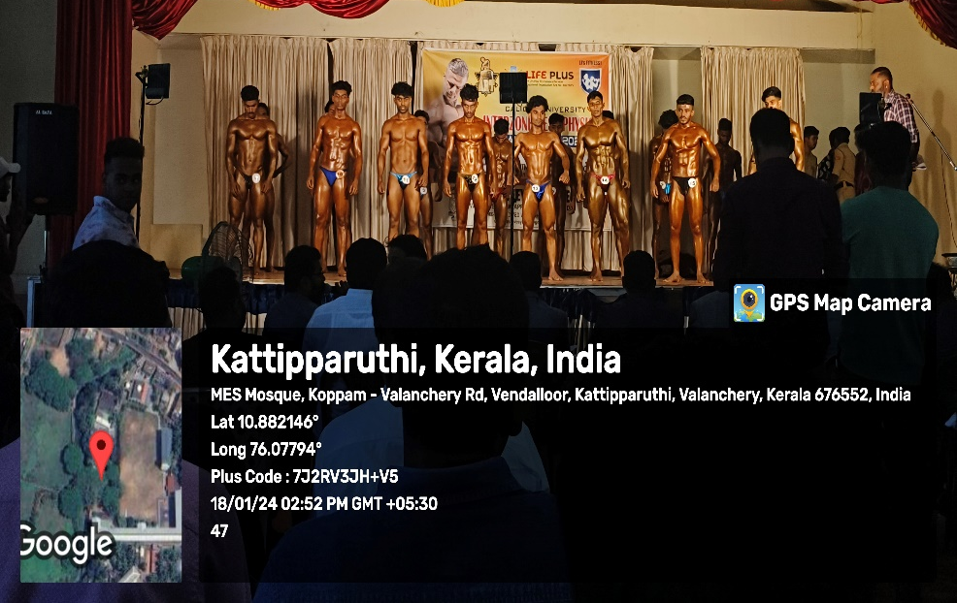

- ANNUAL SPORTS MEET 2023-2024 —22/01/2024-07/02/2024

The Annual Sports Meet 2023-24, organized by the Department of Physical Education in association with Baahar Students Union, featured a thrilling event named GoRACE. Teams including the Dynamos of Management, Raptors of Arts, Titans of Science, and Spartans of Commerce competed fiercely across various games such as volleyball, cricket, chess, carroms (men's), throwball, small post penalty shoot-out, and dodgeball (women's). The climax was the Athletic Meet on the last day, where nine track and field events took place. The Spartans of Commerce emerged as the Overall Champions, with the Dynamos of Management securing the 1st Runner Up position and the Titans of Science claiming 2nd Runner Up. The prizes were distributed by Dr. Ayoub Keyi (college principal).

